# Analysis of Bushfires in the Grampians

BY JEREMY KLAUBER

## Acknowledgement

A great thanks for Dr Savin Chand for guiding me through this process, and Soubhik Biswas for supplying the data used to conduct this analysis.

## Background and Method

Bushfires in Australia have been a recurrent and significant natural hazard that has shaped its land, ecosystem, and communities, causing widespread devastation and destruction with the 2009 Black Saturday bushfires which caused up to 450,000 hectares of land to be burned (National Museum Australia, 2023), and more recently the 2020 bushfires which caused over 3000 houses destroyed in NSW alone (Richards, Brew and Smith, 2020). These fires occur more prevalent during dry months which depending on the location in Australia changes. In Victoria, NSW, and SA the dry season is usually in the Summer this is exacerbated with dry vegetation, low humidity, and occasionally strong winds and the occasional El Nino and La Nina phases known as the Nino-Southern Oscillation (ENSO), which can bring about the most devastating bushfires, as they can bring higher temperature overall and drastically less rainfall (CSIRO, 2023). While this has been a natural occurrence in Australia for thousands of years, in more recent times due to excess human activity and climate change, so far there has been a significant increase in temperature from around 1.5 ℃ since 1850 (Mayfield, Metcalfe & Creagh 2020), on top of increasing flash droughts and extreme heat waves etc, which has caused an increasing rise of bushfires in the past decade, with increasingly longer fire seasons and more devastating bushfires (CSIRO, 2023). Southern states like Victoria have the highest rates of bushfires (Dowdy et al., 2009), with the more recent bushfires in the Grampians region which show large-scale devastation. The Grampians region covers up to 20% of the state, with over 4 million hectares of land (*Grampians Region* 2021). This analytics report will cover bushfire data gathered from the Grampians region acquired from Soubhik Biswas PhD thesis, which will provide data spanning over 70 years of Forest Fire Danger Index (FFDI). The FFDI is used to measure the risk danger in fire prone areas (Dowdy, AJ 2017) it is measured by the following equation:

with T as temperature (), RH for relative humidity (%), wind speed v () and drought factor (DF) which is the fuel availability for ignition sources which start bushfires (Dowdy, AJ 2017).

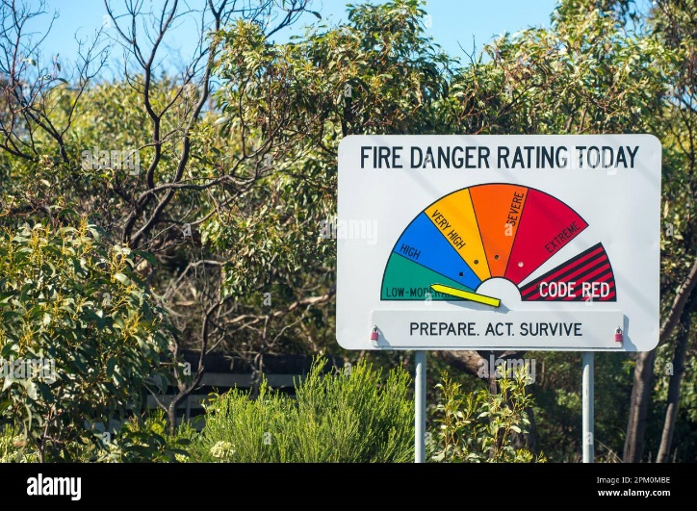These danger levels are usually shown on signs such as shown in figure 1.

Figure 1: Fire Danger Rating, computed using FFDIs

The main objectives for this analytics report will be to see whether the summers are expanding and how much, to see if the FFDIs are increasing and how ENSO effect the results for the FFDIs. This analysis will be conducted using R Studio as the statistical analysis and graphical representation of the results, to allow the interpretation of the data to help conclude each objective. To see if the summers are expanding, we will use R Studios as well as Excel and Minitab to organise and compile the data into segments of each season focusing on summer which will be identified as DJF for December January February. Getting the average of all those months to form the summer season, giving the base summer FFDI averages. Then we will modify the code to check for individual months bordering the summer seasons such as November and March to see if the FFDIs are lining up with the DJF set, and if so, would that indicate an expanding summer. For the second objective, to observe whether the FFDIs are increasing, take in all the FFDIs for each month and identify if there is a clear trend in increasing FFDIs. Lastly will be observing the effect of the ENSOs on the data set. This last objective will be done by observing FFDIs during the El Nino and La Nina during the DJF seasons, to identify the spikes in the data and whether they line up with ENSO.

### Analysis of Increasing Forest Fire Danger Index (FFDI)

The bulk of this analysis is set in R by conducting a time series vector mean for each month and season, filtering the Years and FFDIs for each month spanning from 1950-2020, the series is than reprinted as a new csv and then plotted into a line graph including the slope and trend line. With the first set of results which are for the summer months December, January and February show significant trends FFDIs over the past 70 years. This result is shared throughout all the months and seasons of the Grampians FFDI csv results. The rising bushfire ratings can be attributed to increasing drought factors, as temperatures increase causing many of the landscape to dry far more often and sooner than in the past, this is as well attributed to the effects of climate change. With increasing cause to have better fuel management strategies.

Looking closer the figure shows large spikes throughout the series, these spikes can be correlated to the El Nino and La Nina events, with El Nino causing the highest rise in bushfires. Notable rises can be found in the mid-80s and the mid-90s, this figure coincides with the Ash Wednesday fires in 1983, which resulted in over 25 thousand hectares of land destroyed and over 700 building destroyed (Grampians Region, 2021) and another event in the mid-2000s, where from the figure shows a very high FFDI rating, which found a large amount of fire breakouts which included the Mt Lubra Fire in the Grampians region (Forest Fire Management Victoria 2019).

A further look into the statistical results for the DJF time series were also conducted, showing the adjusted R-sq, F-statistic and p-value of the predictor coefficient found in table 1. Interpreting this data, the R-sq coefficient reveals that approximately 42% of the variability in the DJF FFDI can be attributed to the years. This suggests that factors beyond the annual progression may significantly influence FFDI variations. Notably, rising human activity, periodic occurrence of ENSO events such as El Nino and spanning bushfire seasons likely contribute to the variability, as depicted in Figure 1.

Examining the p-value associated with the year coefficient reveals a statistically significant relationship between the years and the FFDI values at a 5% significance level. This underscores the noteworthy trend of increasing bushfire occurrences in the Grampians over the past 70 years, a pattern consistent across all months and seasons from 1950 to 2020.

Finally looking at the F-Statistic, the analysis shows that there is a strong overall relationship between the years and the FFDI values. Specifically, the variation in FFDI values is largely explained by the years, supporting the idea that there is a meaningful association between the passage of time and changes in fire danger.

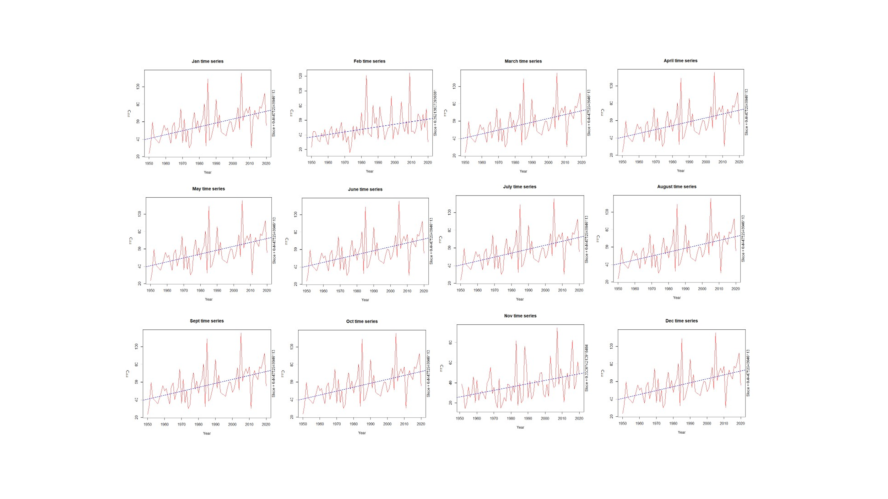In conclusion, the analysis underscores the pressing need for comprehensive understanding of long-term trends in Forest Fire Danger Index (FFDI) and the factors driving escalating fire danger in the Grampians region. The significant increase in FFDI values over the past 70 years, coupled with strong annual influence observed in the regression analysis, highlights the critical importance of proactive fire risk management strategies to mitigate the impacts of bushfires.

Figure 2: Rising FFDIs from 1950-2020

Building upon these findings, leads to the next objective of this study which will focus on examining the annual dynamics of bushfire seasons in the Grampians region. Specifically, investigating the lengthening of bushfire seasons and the occurrence of earlier fire events. By conducting further investigations into the Grampians FFDI data, imploring other resources such A screenshot of a data analysis
as excel to assist in determining the spanning bushfire seasons, to help predict the occurrences of bushfires in the future.

By integrating the findings from the FFDI analysis with the examination of bushfire season dynamics, to develop a more comprehensive understanding of the evolving fire risk landscape in the Grampians region. This holistic approach will enable the identification of key trends and drivers of fire activity, ultimately supporting the development of effective strategies to enhance resilience and mitigation of the impacts of bushfires in fire-prone ecosystems.

### The Spanning Bushfire Seasons in the Grampians Region

As we have established through analysis of the FFDIs, the Grampians region has experienced a significant increase in fire danger over the past decades. This rising trend shows the urgent need to understand not only the intensity but also the timing and duration of bushfire seasons. To develop a more comprehensive understanding of the evolving fire risk landscape, it is essential to integrate these findings with an examination of bushfire season patterns.

This next section will focus on investigating the increasing length and earlier onset of bushfire seasons in the Grampians region. By analysing historical data on fire occurrences, with the aim to uncover how the duration and timing of bushfire seasons have shifted over time. This analysis will help identify key trends and drivers behind these changes, providing crucial insights into the factors contributing to the extended periods of heightened fire risk. Understanding the expanding bushfire seasons is critical for creating increase safety measures and effective mitigation strategies in fire-prone ecosystems. By examining these patterns, to better anticipate future fire risks and improve preparedness measures, ultimately supporting the development of more robust fire management policies.

The following section, will delve into the patterns of bushfire season duration and timing, exploring how they have evolved and the implications for fire risk management in the Grampians region.

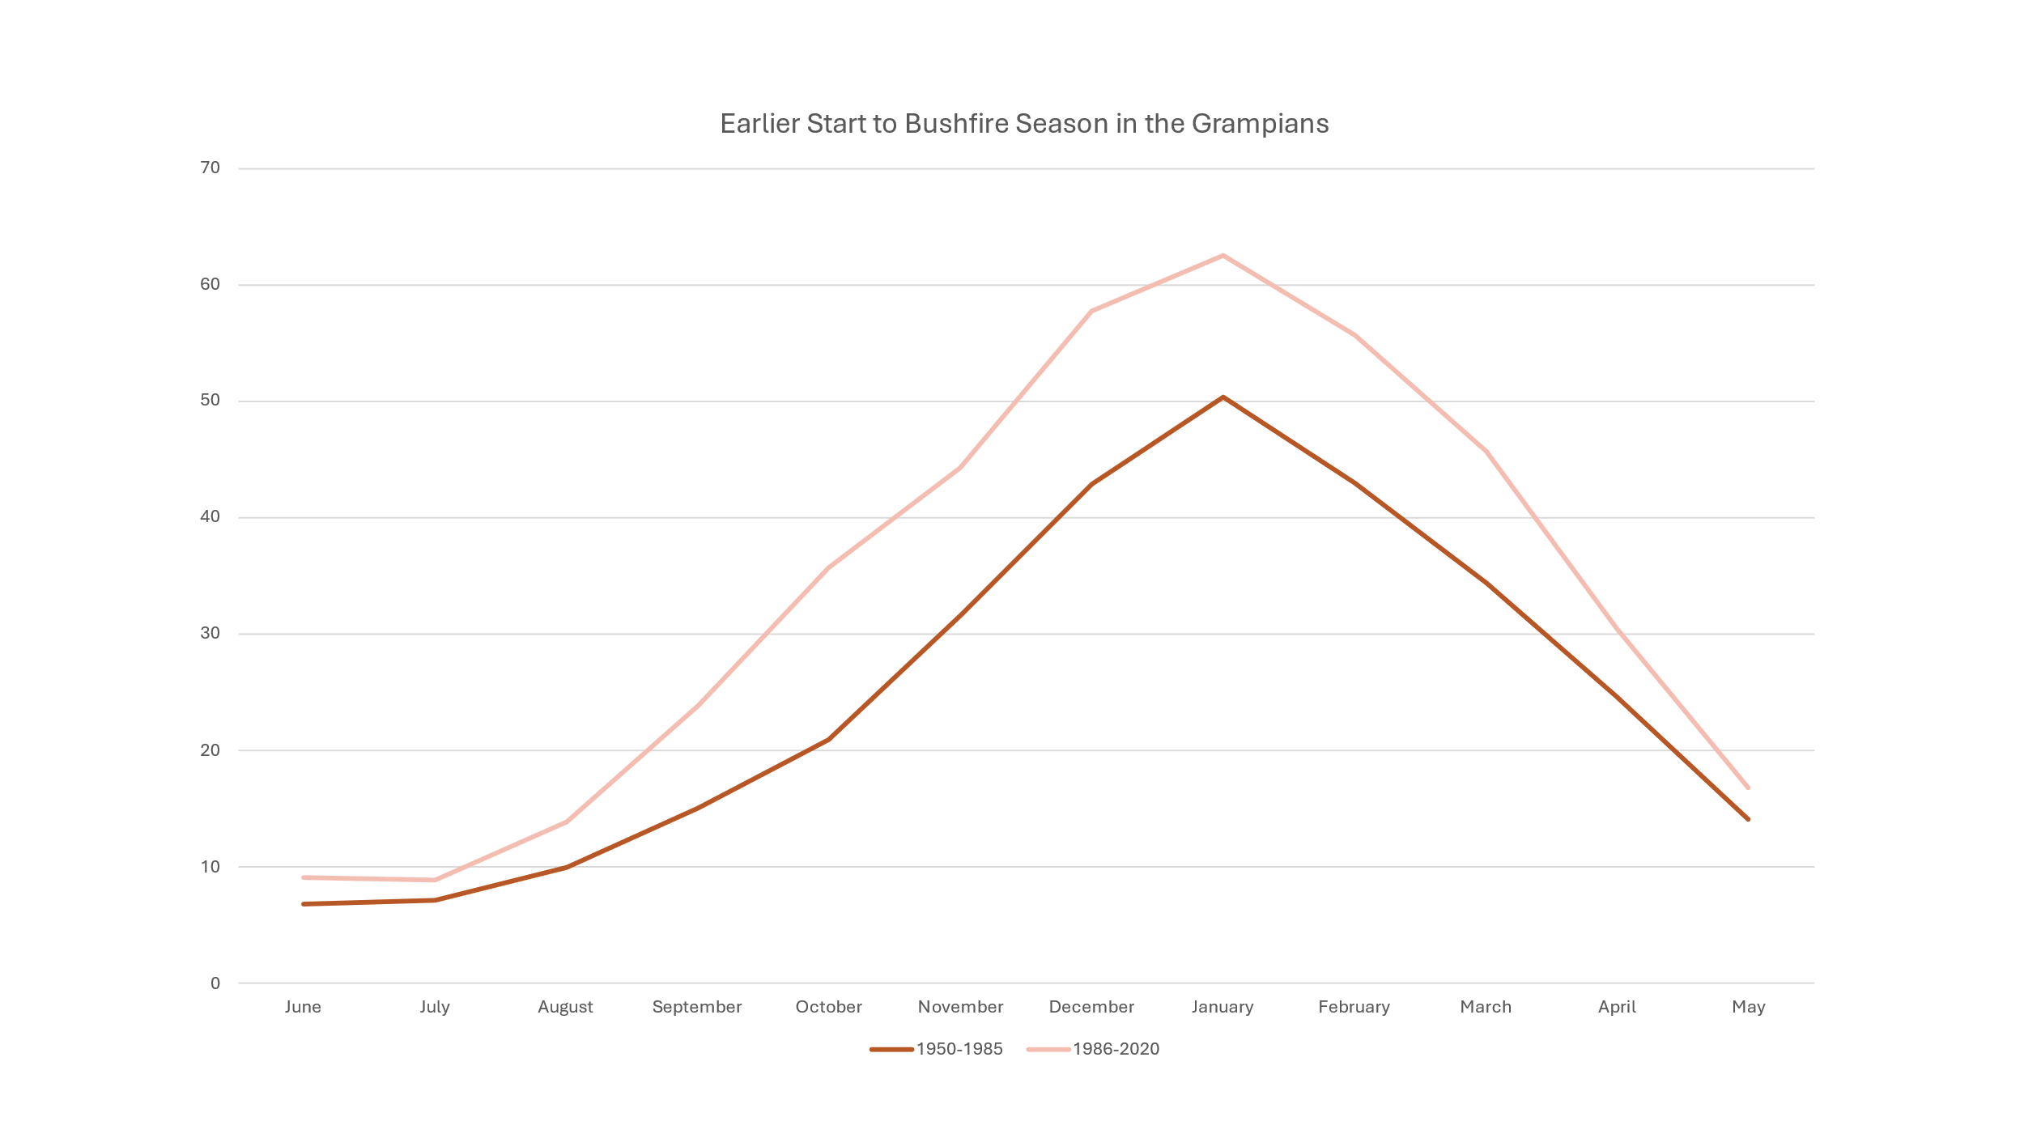

Figure 3: Average FFDI months in sections 1950-1985 and 1986-2020

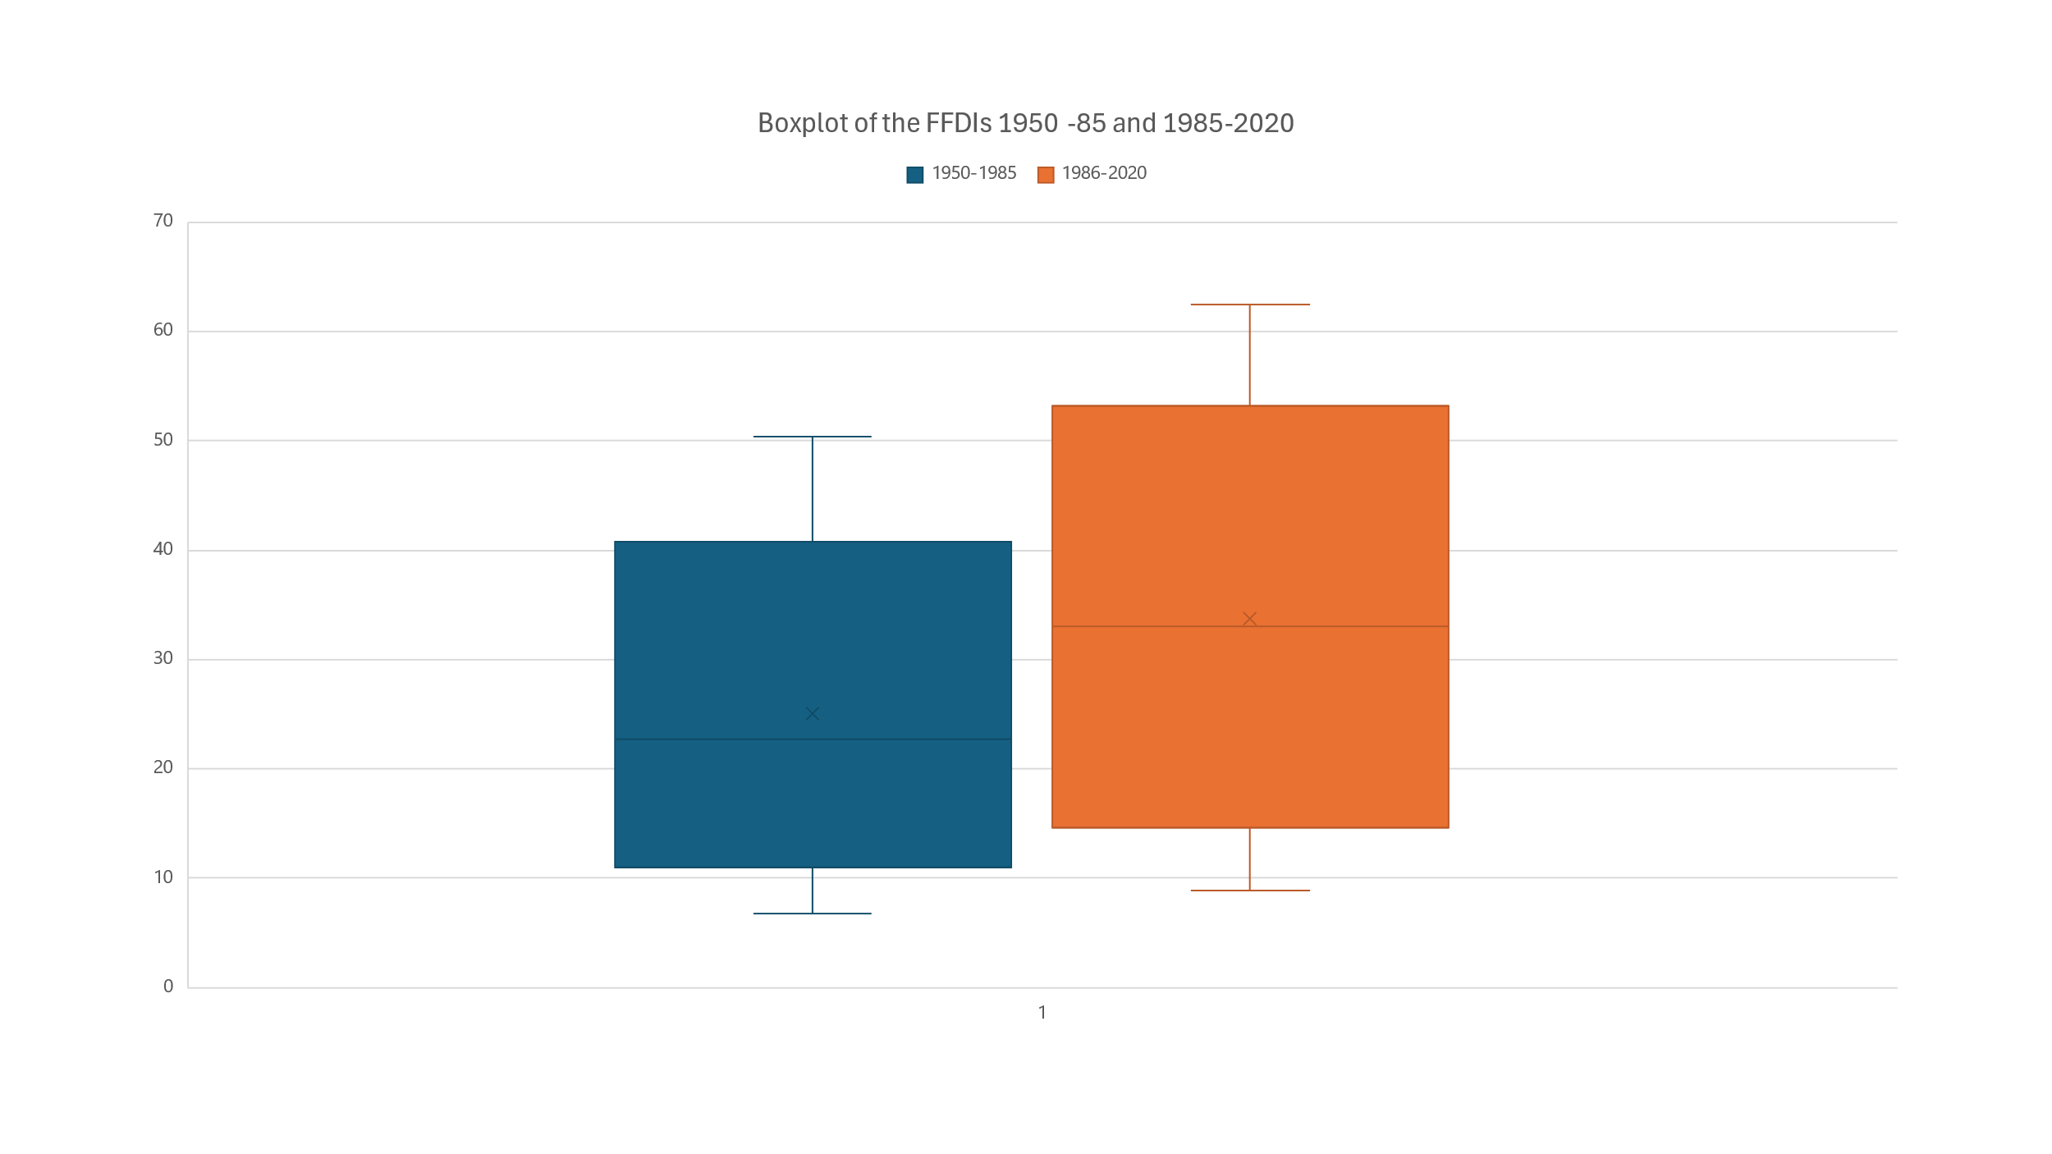To give a real good picture on how the bushfire season is expanding is as was done in this analysis, to take all the average FFDI’s for each month in year brackets, 1950 to 1985 and from 1986 to 2020. From here there can clearly see an earlier onset high bushfire risk in November and December of 1986-2020. Where November FFDI’s have risen in the last 3 decades to cause for earlier bushfire seasons. This can be seen as well in figure 3 where the boxplot describes, how in the last 3 decades FFDIs have risen by a substantial amount, especially in the summer months. Dates like March and November are now seeing similar FFDIs as are found in the summer months during 1950-85. This evidence is then agreed with various increasing bushfires that have occurred throughout the 21st century, with Black Saturday 2009 which began around February and ending in around March. As well as the Black Summer of 2020 where the bushfire season was claimed to have started as early as 21st November 2019 with these bushfires rage until the end of May 2020 (Australian Institute for Disaster Resilience 2020).

Figure 4: Boxplot of the average FFDI's in sections 1950-1985 and 1986-2020

Overall, this section has showed that there is indeed an increasing risk of bushfires throughout the Grampians region and beyond, as rising FFDI’s and major bushfire events become more prevalent every year. This data was acquired with the goal to increase the measures needed for bushfire prevention, as it is now more than a time to begin implementing better strategies to combat these increasing fire danger risks.

The next objective will be understanding the El Nino Southern Oscillation and how it affects the fire danger in the Grampians region. As mentioned before the large spikes in the FFDI’s and the extra explainability in the graph, can lead to these global climate phenomena, for which they bring the most devastating bushfires.

### The Effect of The El Nino Southern Oscillation on Bushfires in the Grampians Region

El Nino Southern Oscillation (ENSO) is one of the most impactful weather events to affect the Earths climate from far reaching hazards and incredible, as well as spanning incredible time. El Nino events are characterised with increasing temperatures and dryer weather, while vis versa La Nina events are led by greatly increased rainfall and cooler weather. Both which interns led to increasing and decreasing FFDI’s with El Nino’s leading to some of the most devastating bushfires in Australia. The way the ENSO is observed is through sea surface temperatures within the pacific tropics with a device called NINO3.4 (BOM 2021).

Figure 5: Monthly ENSO outlook taken from the BOM website, counting historical data from 1980-2024, showing the changes in the Southern Oscillation over time

The results of these findings are posted on the Bureau of Meteorology Australia website. Here we can see the various changes in the FFDI’s throughout the decades from 1980 to 2020, with blue representing the La Nina events and the red representing El Nino events. By observing this data we can see various important dates that correlate the El Nino events to the most extreme bushfire events. With the 1983 Ash Wednesday fires and the 2006 Mt Lubra fires (Grampians Region, 2024), it is shown that full El Nino events were recorded at those times. These fires were amongst some of the most devestating fires for the grampians regions, as well as the recent fires of 2024 where we can see as well an El Nino event starting as soon as August ending in March the next year. These events can attribute to the expanding fire danger risk in the previous section, as the data is based on the fire danger which includes as stated before, dry weather, increasing temperature, high winds and rising drought factors, which all contribute to a increase in FFDI’s. We can see these FFDI increases even closely through a boxplot graph generated using R Studio.

Figure 6: Boxplot of the DJF FFDI Segregated by ENSO Phases

Here in figure 5, we can see a substantial increase in bushfire risk during the El Nino phase compared with a La Nina and Neutral phase. With some FFDI’s reaching over 80 in danger level. The analysis of the ENSO has revealed a substantial impact on the bushfire activity in the Grampians region. El Nino events, have clearly led to the most severe and widespread bushfires, as stated above those including, the 1983 Ash Wednesday, 2006 Mt Lubra and the 2024 Grampians bushfires, all occurring during a El Nino period, describing the immense influence of these climate phenomena.

The La Nina events, conversely show lower FFDI values due to increased rainfall and cooler conditions, thereby reducing bushfire risk. The statistical evidence, including the boxplot analysis, clearly demonstrates the rise in FFDI values during El Nino phases compared to La Nina and Neutral periods. This correlation highlights the necessity for enhanced bushfire preparedness and management strategies during predicted El Nino periods to mitigate the devastating effects of increased fire danger.

### Conclusion

Overall, this comprehensive analysis of bushfire activity in the Grampians region shows the escalating fire danger over the past decades. This increase is driven by a combination of climate change, rising temperatures, prolonged droughts and significant climate phenomena such as ENSO. The study’s objectives which included examining the rise in FFDIs, the expanding bushfire seasons and the impact that ENSO brings to these danger levels have been met with clear evidence showing longer strong correlations and increased bushfire activity.

Key findings include the marked rise in FFDI values across all seasons, particularly during summer months, and the lengthening of bushfire seasons into November and March. The ENSO analysis further expanded the heightened fire risk during El Nino periods, reinforcing the critical need for vigilant fire management strategies.

In conclusion, the escalating bushfire risk in the Grampians region necessitates proactive and adaptive fire management policies. This includes improving fuel management, enhancing early warning systems and developing robust response strategies to mitigate the impacts of bushfires. As climate change continues to influence weather patterns, understanding these dynamics becomes ever more crucial in safeguarding communities and ecosystems from the increasing risk of bushfires

## References

Biswas, S. (2023). *Statistical assessment of Australian bushfire conditions : long-term changes and variability*. [Thesis: PHD] p.289. Available at: https://researchonline.federation.edu.au/vital/access/manager/Repository/vital:18293;jsessionid=69065D8E43FBC7577C358E3223554074 [Accessed 3 May 2024].

Dowdy, AJ 2017, *Climatological Variability of Fire Weather in Australia*, Bureau of Meteorology, Docklands, Victoria, Australia

Dowdy, A.J., Millis, G.A., Finkele, K. and Groot, W. de (2009). *Australian fire weather as represented by the McArthur Forest Fire Danger Index and the Canadian Forest Fire Weather Index* . Victoria, Australia: Bureau of Meteorology.

Bureau of Meteorology 2022, *State of the Climate 2020: Bureau of Meteorology*, Bom.gov.au, Bureau of Meteorology.

Australia state of the Environment 2021, *Bushfires and wildfires | Australia state of the environment 2021*, https://soe.dcceew.gov.au/extreme-events/environment/bushfires-and-wildfires

Climate Council (2019). *The facts about bushfires and climate change*. [online] Climate Council. Available at: https://www.climatecouncil.org.au/not-normal-climate-change-bushfire-web/.

‌*Early Fire Season Outlook for 2023/2024 Season In Australia* 2023, www.tracplus.com, viewed 15 May 2024, https://www.tracplus.com/tracplus-blog/early-fire-season-outlook-for-2023/2024-season-in-australia.

Bureau of Meteorology 2021, *What is El Niño and what might it mean for Australia?*, Bom.gov.au.

‌NOAA (2000). *El Niño & La Niña (El Niño-Southern Oscillation) | NOAA Climate.gov*. [online] Climate.gov. Available at: https://www.climate.gov/enso.

‌

www.noaa.gov. (n.d.). *El Niño Southern Oscillation (ENSO)*. [online] Available at: https://www.noaa.gov/jetstream/tropical/enso.

Clarke, H., Lucas, C. and Smith, P. (2012). Changes in Australian fire weather between 1973 and 2010. *International Journal of Climatology*, 33(4), pp.931–944. doi:https://doi.org/10.1002/joc.3480.

Clarke, H. and Evans, J.P. (2018). Exploring the future change space for fire weather in southeast Australia. *Theoretical and Applied Climatology*, 136(1-2), pp.513–527. doi:https://doi.org/10.1007/s00704-018-2507-4.

Harris, S. and Lucas, C. (2019). Understanding the Variability of Australian Fire Weather between 1973 and 2017. *PLoS One*, 14(9). doi:https://doi.org/10.1371/journal.pone.0222328.

‌

Mayfield, P, Metcalfe, D & Creagh, B 2020, *Climate and Disaster Resilience*, *csiro.au*, CSIRO, p. 55, viewed 16 May 2024, https://www.csiro.au/~/media/Environment/CSIRO-Report-Climate-and-Disaster-Resilience-Overview.pdf?la=en&hash=684B38B8A539D720E5A3B75E3DF5A92A45CD6006.

‌

National Museum Australia (2023). ‘Black Saturday’ bushfires | National Museum of Australia. *Nma.gov.au*. [online] doi:https://www.nma.gov.au/defining-moments/resources/black-saturday-bushfires.

‌

Richards, L., Brew, N. and Smith, L. (2020). *2019–20 Australian bushfires—frequently asked questions: A quick guide*. [online] Parliament of Australia. Available at: https://www.aph.gov.au/About_Parliament/Parliamentary_Departments/Parliamentary_Library/pubs/rp/rp1920/Quick_Guides/AustralianBushfires.

‌

CSIRO n.d., *Expert Commentary: 2023/24 El Niño for Australia*, www.csiro.au, viewed 15 May 2024, https://www.csiro.au/en/news/all/news/2023/september/expert-commentary-el-nino..

*Grampians Region* 2021., https://bushfireplanning.ffm.vic.gov.au/grampians/

Forest Fire Management Victoria 2019, *Past bushfires*, Forest Fire Management Victoria.

‌

NOAA's Climate Prediction Center 2017, *Climate Prediction Center - ONI*, Noaa.gov.

Australian Institute for Disaster Resilience, 2020, Black Summer bushfires Vic 2019-20, viewed 7 June 2024, <https://knowledge.aidr.org.au/resources/black-summer-bushfires-vic-2019-20/>

Bureau of Meteorology, 2024, ENSO Outlook, viewed 7 June 2024, <http://www.bom.gov.au/climate/enso/outlook/>

‌